

|  |  |
| --- | --- |
| **Jackson-Pratt Drain** | Printed on 2022-06-15 |
| You must carefully read the "Consumer Information Use and Disclaimer" below in order to understand and correctly use this information | |

**Why is this procedure done?**

In some cases, fluid gathers in the wound area after a surgery. This fluid may raise the chance of infection. It also slows down the healing process. When this might happen, the doctor may put in a drain to bring the fluid outside the body.

A Jackson-Pratt, or JP drain, may be used to help get rid of the extra fluid from around the cut site. A JP drain is made up of two parts. The first part is a thin rubber tube. The other part is a soft bulb with a removable stopper. The bulb acts as suction and a container to collect the fluid from the body.

**Image(s)**

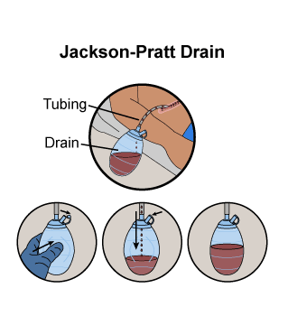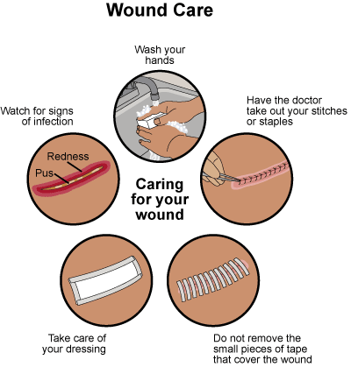

**What will the results be?**

This drain gets rid of extra fluid from your cut site. This will help it to get better faster.

**What happens before the procedure?**

* Talk to the doctor about all the drugs you are taking. Be sure to include all prescription and over-the-counter (OTC) drugs, and herbal supplements. Tell the doctor about any drug allergy. Bring a list of drugs you take with you.
* Any bleeding problems. Be sure to tell your doctor if you are taking any drugs that may cause bleeding. Some of these are warfarin, rivaroxaban, apixaban, ticagrelor, clopidogrel, ketorolac, ibuprofen, naproxen, or aspirin. Certain vitamins and herbs, such as garlic and fish oil, may also add to the risk for bleeding. You may need to stop these drugs as well. Talk to your doctor about them.
* Ask your doctor if you may eat or drink anything before the procedure.
* You will not be allowed to drive right away after the procedure. Ask a family member or a friend to drive you home.

**What happens during the procedure?**

* During surgery, your doctor will put one end of the rubber tube into the area where there is extra fluid. The tube will be held in place by a stitch in your skin.
* The other end of the rubber tube is hooked to the bulb. The doctor will then remove the stopper. The doctor squeezes the bulb to get rid of the air. The stopper is put back on the bulb and this makes suction inside the drain. The excess fluid will be pulled out of your body.
* It may only take a few minutes to put in the drain.
* You will not be awake if the drain is put in during surgery.

**What happens after the procedure?**

* You may be sore where the drain was put in. Your doctor will give you drugs for the pain.
* You may need to stay in the hospital until you are well enough to go home. Your doctor will watch to see how much fluid is in the bulb each day.
* The nurses will empty the drain when it gets about half full or at certain times during the day and measure the amount of fluid emptied.

**What care is needed at home?**

* Ask your doctor what you need to do when you go home. Make sure you ask questions if you do not understand what the doctor says. This way you will know what you need to do.
* You will learn how to:
  + Wash your hands every time before and after you empty the drain or change your bandage.
  + Care for the skin around the site where the tube goes into your body.
  + Empty the drain. Remove the stopper at the end. Pour out the drainage. Your doctor may want you to measure how much drainage is in the bulb. Then, squeeze the bulb to get rid of air and put the stopper back in place.
  + Care for the tube if there is a clot in it. The doctor may tell you to squeeze the tube over the clot. You can also squeeze the tube from your skin to the bulb and then let it go. This should open the tube. Ask your doctor to show you how to do this before you go home.
  + Measure the amount of fluid in the drain ball after you empty it each day and write it down on a chart.
  + Look for signs of infection. Your doctor will want to know if you have a fever of 100.4°F (38°C) or higher, chills, if you get very red and sore around the drain, or if the fluid in the drain turns cloudy or smells. Your doctor will want to know if the skin around the drain has any fluid or pus coming out of it.
* Sleep on the side opposite to the JP drain. This prevents any kinking of the tubing or pulling out the suction bulb.
* Avoid bumping the drain.
* Your doctor may want you to hold the drain up with a safety pin while you are moving around. Ask your doctor to show you how to do this.
* Talk to your doctor about when it is safe to take a bath or shower. Ask your doctor about your activity level while you have your drain in place.

**What follow-up care is needed?**

* Your doctor may ask you to make visits to the office to check on your progress. Be sure to keep these visits.
* Your doctor will tell you when the drain may be removed.

**What problems could happen?**

* Fluid leaking from the cut site
* Bleeding
* Infection
* Clot in the tube
* Tube and drain falls out
* Cut area opens up
* Drain stops working

**When do I need to call the doctor?**

* Signs of infection at the drain site. These include swelling, redness, warmth around the wound, too much pain when touched, yellowish or greenish or bloody discharge, foul smell coming from the cut site.
* Drain becomes loose, comes apart, abruptly stops draining, or falls out

**Last Reviewed Date**

2019-09-24

**Reference**

https://online.lexi.com/lco/action/doc/retrieve/docid/disandproc/3658059?cesid=9cjXv4m1165&searchUrl=%2Flco%2Faction%2Fsearch%3Fq%3Djackson%2Bpratt%26t%3Dname%26acs%3Dfalse%26acq%3Djackson%2Bpratt